Stickers: individual size of each sticker is 32 cms (1.25 inches)
- Consultants find both adults and children enjoy this fun way to take home their Homeplay movements. Stickers can be used on the celebration posters or on a memo sheet as a reminder of the goal and follow-up movements.
- Instructors find people appreciate using a sheet in classes and presentations to assist in reviewing the movements they have done.
- Children love to make their own games and personal grab bags.

Brain Gym® Movement Stickers -30 stickers in three colours

Drawings of people illustrating all 26 movements and an extra set of PACE on one convenient sheet. Colour reflects the dimensions: Focus movements are in red, Centering movements in green and Laterality movements in blue.

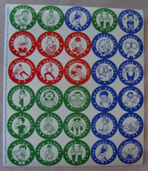

Description | Price per sheet in Australian $s
 | 1-49 | 50-99 | 100 or more
Brain Gym Movement Stickers | $1.50 each | $1.40 each | $1.25 each

PACE Stickers : 48 stickers in three
colours per sheet
12 Sets of PACE movements on an A4 sheet.
Feature four unique Australian animals finding their PACE.

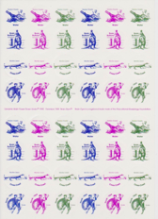
Description | Price per sheet in Australian $s
 | 1-9 | 10-24 | 25-49 | 50 or more
Aussie Animal  PACE stickers | $2.00 each | $1.50 each | $1.40 each | $1.30 each
Every sheet has 4 sets of PACE in each colour green, blue, and purple.

Brain Gym® Caps-

Black, yellow and green available.

“Brain Gym Works!”on the cap.
Legionnaire hats: yellow, red, navy, blue, green
Limited number.
$6 /cap

Celebration Posters – games and success certificates for Homeplay
Permission to copy is granted for educational purposes, not for resale.
Copy on to a range of colours to give your clients or students choice.
Description | Price each in Australian $s
5 celebration master charts | $12
Celebration Pack  5charts +15 sheets stickers | $30

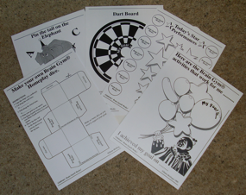

Brain Gym® Menu Charts
Bold reflex blue print on washable calico cloth shows the Brain Gym movement names and page numbers in the orange Brain Gym book. Ideal for travelling as it is light and folds or rolls neatly into your briefcase or PACE bag. Hang one in your office or classroom. It is conveniently hemmed to allow you to insert your choice of rod top and bottom for easy hanging.
Approx. 92cm x 92cm, 3’ square (Rods and cord not included.)

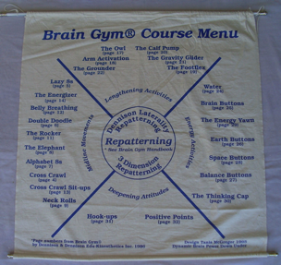

Description | Price each in Australian $s
 | 1-9 | 10 or more
Brain Gym Menu Charts  1st grade | $25 | $20
Brain Gym Menu Charts  2nd grade | $20 | $15

PACE Bags
A range of styles to store your Brain Gym menu, stickers and memo pads.
Instructors can use a different coloured bag for each Brain Gym dimension.

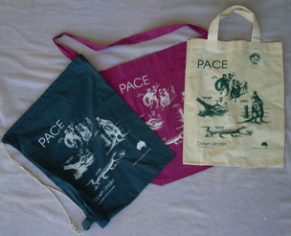

Description | Price each in Australian $s
 | 1-4 | 5 or more
PACE Bags Coloured  with white print | $6 | $5.50
Specify styles:
2 short handles (33cm), shoulder bag, drawstring
Colours with white print: Bottle Green, Royal Blue, Rose
PACE Bags Natural calico with green print | $6 | $5.50
Specify styles: 2 short handles (33cm), shoulder bag

Memo Pads
Convenient size for recording client’s goal and homeplay. Handy for brief notes.
Use them for your shopping list and benefit from the positive messages or timely
reminders for a Brain Gym movement.

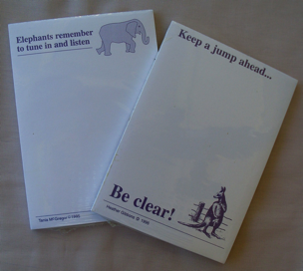

Description | Price of each pad in Australian $s
 | 1-9 | 10 or more
Print colour: purple  50 sheets per pad  74mm X 103mm (3” X 4”) | $1.50 each | $1each
Assorted Titles:
• Be Energetic. Drink Water
• Be Active! Take your brain for a walk.
• Elephants remember to tune in and listen
• Get connected with success
• Keep a jump ahead. Be clear!
• Relax your eyes and re-focus
• Touch here. Let go of stress.
• You have a choice!

Contact Heather Gibbons : hgibbons55@westnet.com.au
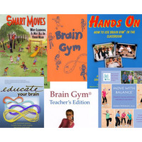
Books, Charts etc
For Edu-K books and manuals and other resources, contact Michael Wild at Equilibrium Kinesiology Supplies (Taradale, Vic) email: orders@kinesiologyshop.com
Check the website: www. braingym.com.au ph 03 5423 2230
Instructor discounts available for class supplies.

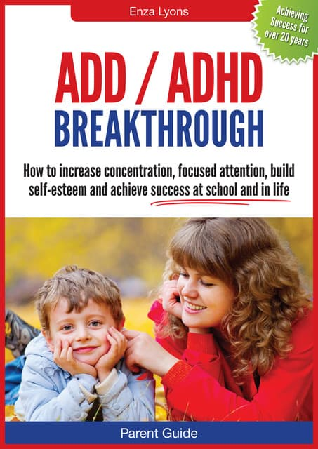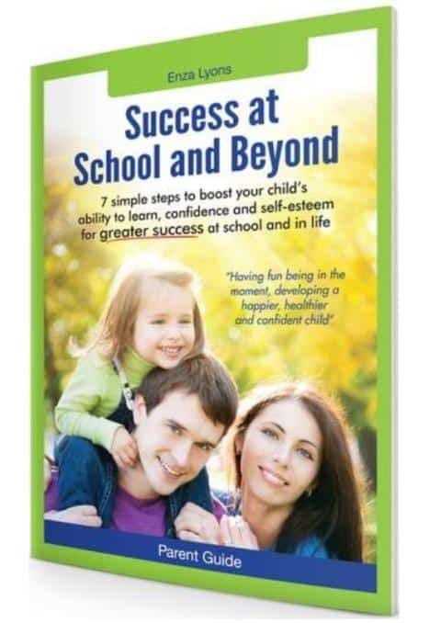

Australian books of testimonials:
Enza Lyons: enzalyons1@gmail.com
see BGA website

Australian Brochures

There are coloured brochures, which are available for purchase by professional members. eg.

1. Brain Gym® 101
2. Training in Educational Kinesiology.

Contact Julie Gunstone, juliegunstone@gmail.com to order.

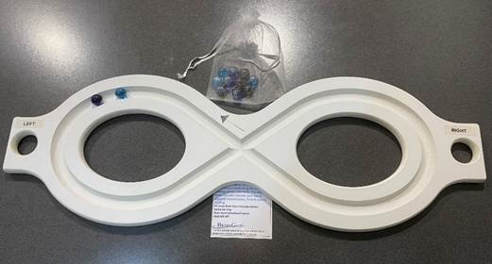

Lazy 8 Marble tracking boards supports-
- Bi-lateral integration.
- Encourages eye tracking and teaming.
- Reading in the midfield and peripheral vision.
- Focus, concentration, and sensory integration.
- Cognitive function.
- Has a calming effect.

Feature of these boards are –
- Light weight, durable and easy to clean
- Finger holds at the end of the board for easier use, perfect for individuals with ABI, stroke, dementia, or the loss of the use in one hand/arm.
- Sits easily across the arms of a wheelchair.
- Easy hanging storage.

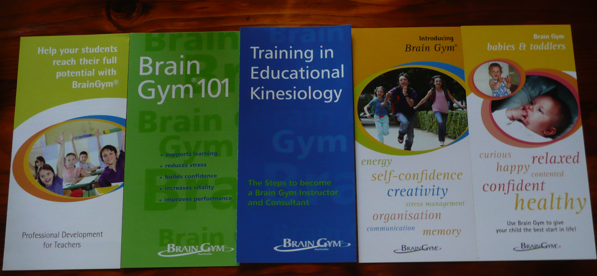

Lazy 8 Marble Tracking Boards

The boards can be claimed under NDIS plan – Assistive Technology and Consumables.

They are suitable for all ages, children to elderly and all abilities.

Each board comes with a bag of 10 coloured marbles, instructions for use and a free 30 zoom session on ways to use the board.
$110 each plus postage in Australia.

Contact Katharine King: Katharine@kkingconsulting.com.au
Book here- https://www.trybooking.com/CAHWC

